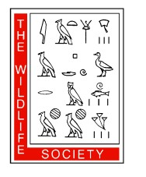
Canadian Section and Ontario Chapter of TWS Student Travel Award Application
CSTWS/OCTWS Annual Conference, 27 – 29 March 2020

Peterborough, ON
Application Deadline: March 2, 2020

Applicant Information

Name (Last, First):

Email Address:

Mailing Address:

University:

Degree Sought:

Expected or Actual Graduation Date:

Summary of why you are the best applicant to receive this grant. (maximum 500 words)

Summary of Conference Travel Budget
Air travel | $ ____________
Vehicle travel | $ ____________
Accommodations | $ ____________
Conference registration | $ ____________
Total projected costs | $ ____________
Funding from other sources | $ ____________
Funding requested from the Canadian Section | $ ____________

Abstract (maximum 250 words)

Membership

Are you a member of the Canadian Section of TWS? Yes ___ No ___

Are you a member of the Ontario Chapter of TWS? Yes ___ No ___

Verification

The undersigned assure that the information supplied is true, that the applicant meets the eligibility requirements as stated herein, and that the financial need as stated is accurate.

Student Signature Date

Advisor Signature Date

Please submit the full application form to joseph.northrup@ontario.ca with the subject line: LastName_TWS_Travel2020.

